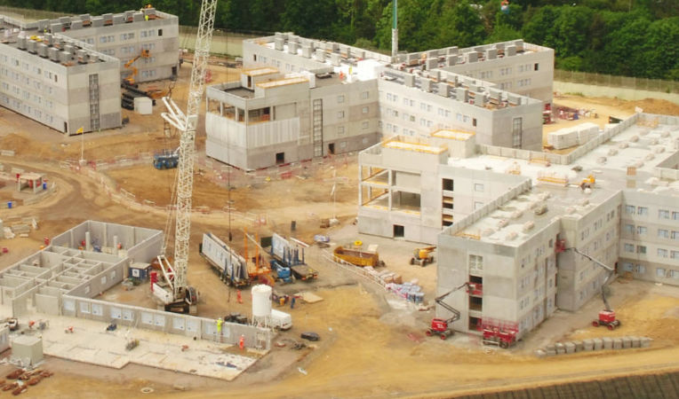
NO MORE PRISONS HERE
How can this be screened?
HOUSE PRICES TO FALL?
IS THIS WHAT WE WANT TO SEE IN OUR LOCALITY?
BEWARE, THIS IS COMING UNLESS LOCALS CAN ACT TOGETHER AND RAISE THOUSANDS OF OBJECTIONS
The Ministry of Justice (MoJ) is seeking the views of residents and businesses in the area on plans for a potential new prison on land adjacent to the current HMP Grendon/Springhill. Full details of the proposed new prison can be found on the website:
https://www.gov.uk/government/consultations/potential-new-prison-in-buckinghamshire-public-consultation
- The proposed new prison will be Category C of 6/7 four storey blocks built on the highest point in the area accommodating 1,440/1,680 inmates plus expansion of HMP Springhill. If you can see them they can see you. The current prisons of Grendon and Springhill have a combined capacity of less than 600 inmates.
- The proposed new prison combined with Grendon and Springhill will make this the largest prison complex in the UK.
- There will be 1,000 people working on site at any one time during construction, which will take around 3 years, and the completed prison will provide 500 to 700 permanent jobs.
- It is expected that the majority of residents in villages in this area of North Bucks will be strongly opposed to this new prison.
THE IMPLICATIONS OF THE PROPOSED NEW PRISON ON YOU:
- The value of your property is likely to be reduced.
- The ability to sell your property is likely to be affected due to the proposed prison being highlighted in solicitors’ searches.
- There would be a substantial increase in local traffic including that using the ‘local rat runs’ through other villages to access the site. New ‘rat runs’ are also likely to be created due to traffic volumes on main routes to the site.
- It is most likely that the new prison will consist of 7 four story blocks housing 1,680 prisoners requiring 700 staff producing up to 350 visitors a day to the area.
- If HMP Springhill is extended then this may lead to an increase in absconders and probably result in an escalation of incidents of drugs, alcohol, mobile phones and other items being left in hedge rows by bus shelters and the like.
- The 500-700 staff recruitment and housing requirements cannot be met locally so they will have to travel in from surrounding areas, creating an additional 1,400 vehicle movements a day. Or a much larger housing estate than Springhill will be built nearby.
To stand any chance of preventing this development going ahead it will take a significant number of well-structured and specific objections to be submitted to the MoJ, Bucks Council and our MP. So please have your say and make sure that you do respond before the deadline (29th January 2021).

See the table below for more details which can be used in your response
Local Impact | MoJ Claim | Reality Check
- The damage to the environment will be significant with the loss of much green space.  - The new prison will need to be well lit at night for security reasons resulting in much light pollution.  - This area is prone to flooding and concreting over the fields will make the flooding worse. | “The prison, if approved, will also make a substantial contribution to the UKs fight against climate change by having almost no carbon emissions.”  “The aim for travel to and from the site after completion is to minimise single occupancy car journeys.” | What is the point of having almost no carbon emissions if the environment is already being destroyed not only by the new prison but also during its construction period?  In addition, there will be increased carbon emissions from the journeys made by the large increase in staff working at the new prison. As there is insufficient local housing for the new staff they will travel to the site from a wide area making car sharing a pipe dream.
- 1,000 people involved in the construction will put too much pressure on the local roads which are already struggling to cope with HS2 and EWR construction traffic. A recent traffic survey carried out in Edgcott shows a daily average of 3,436 vehicles passing through the village.  - 500 to 700 permanent jobs plus daily visitors will result in a daily movement of at least 1,400 up to 2,100 vehicles for which the local roads are not designed. | “We also recognise that a considerable amount of construction traffic is already using local roads. We would work with the Council on a Construction Traffic Management Plan to ensure that any construction traffic movements are co-ordinated” | The unclassified rural road through Edgcott is already carrying around 3,500 vehicles per day on average. Large numbers of HGV’s using the road are increasing due to the EWR and HS2 major works in the locality and there is a forecast of additional sub 7.5tonnes traffic using the road from these projects of over 500 vehicles a day. HS2 and EWR works are forecast to coincide with the timeframe expected for the development works for the prison.
- House prices are likely to fall and property will be difficult to sell if a new prison is built here. Some residents are already suffering as can be seen in correspondence received from a local resident:  I just thought I’d contact you too to let you know how this has already affected us. We agreed a house sale back in September but our buyers have pulled out, virtually last minute, purely based on the possibility of this prison being built. It was brought up in their searches. The suggestion that house prices will increase is ludicrous as who wants three prisons on their doorstep? It would seem that we won’t be able to sell our house because of it. Our house is back on the market but the searches will continue to bring this issue up even though it’s only a consultation exercise. I will look at contacting our MP and counsellors shortly. | “The Ministry of Justice is not aware of any evidence that a new prison in an area leads to a fall in house prices”. | When have you ever seen an estate agents sale particulars quoting a nearby prison as a selling point?  Where will the additional prison staff live? There is insufficient local housing available for 500-700 new staff so will a significant number of new houses be the next local building project? If so where will that be located?
Please act now and ensure that as many people as possible in your household make their views known to the MoJ through the website links https://consult.justice.gov.uk/digital-communications/potential-new-prison-in-buckinghamshire and at the same time inform your MP Greg Smith and local councillor Angela Macpherson at: greg.smith.mp@parliament.uk; Angela.Macpherson@buckinghamshire.gov.uk;

